**ONLINE POLICE STATION CRIMINAL MANAGEMENT SYSTEM**

**A PROJECT REPORT**

***Submitted by:***

**Name of student ID_NO**

Melkamu Chemere-------------------------------TER/4676/07

Lakachew Yibeltal--------------------------------TER/4670/07

Yassab Aziz --------------------------------TER/4696/07

Tesfaye Bayih -------------------------------------TER/4691/07

***In Partial Fulfilment for the Award of the Degree Of***

**BACHELOR OF SCIENCE IN INFORMATION TECHNOLOGY**

Under the guidance of

Gizachewu M. (MSC)

-------------------------------------------

 ADVISOR SEGNATUR

DEPARTMENT OF INFORMATION TECHNOLOGY

INSTITUTE OF TECHNOLOGY

DEBRE MARKOS UNIVERSITY

Debre Marko’s, Ethiopia

December 2010 E.C

# Acknowledgments

First of all we would like to thanks for our God that keeps our life up to this time and giving all strength for successful completion of this documentation. Secondly we would like to thanks for our Advisor Gizachew Melkamu for his great contribution guidance, support and gives us continuous initiation and encouragement from the begging up to the end of the project. We also want to thank for inspector ayalneh who is Debre Marko’s city police station manager and office workers since they provide all the Information about how the current system works. And we would like to thanks for the department of information technology that contribute computer laboratory for the success of the project.

# ABSTRACT

Crime is a human experience and it has to be controlled. Debre Marko’s city police station plays a great role to control crime and criminal activities But the way of managing those criminal and crime activities done manually and this is due to lack of automated system that supports the station workers to communicate with citizen to share information and store, retrieve and managing criminal activities. In order to control crime efficiently we need to develop web based systems.

This project entitled with “online criminal management system” is designed to develop a web application in which any citizen can report crimes; if anybody wants to complaint against crimes he must enjoys with online communication to police station. This project provides to store records of crimes and criminals which have made disciplinary case and used to make simply retrieve information from the database. The system implemented is a typical automated crime management system, based on client-server architecture allowing data storage and criminal record interchange between the police.

Contents

Acknowledgments I

ABSTRACT II

List of Table IV

List of Figures V

Acronyms VI

CHAPTER ONE 1

1.1. Introduction 1

1.2. Background of the project 2

1.3. Statement of the Problems 2

1.4. Objectives of the project 2

1.4.1. General objective 2

1.4.2. Specific objective 3

1.5. Scope of the Project 3

1.6. Limitation of the project 3

1.7. Significance of the Project 4

1.8. System requirement 4

1.8.1. Hardware requirement tool 4

1.8.2. Software requirement tool 5

1.8.3. Programming language 5

1.9. Data collection Methodology 6

1.9.1. Data collection 6

1.10. Feasibility study 6

1.10.1. Operational Feasibility 7

1.10.2. Economic Feasibility 7

1.10.3. Technical Feasibility 8

1.10.4. Legal Feasibility 8

Chapter Two 9

2. System analysis 9

2.1. Over View of Existing System 9

2.1.1. Users of the existing system 9

2.2. System requirement Specification 10

2.2.1. Functional requirement 10

2.2.2. Non-functional requirements: 11

2.2.3. Business rule 12

2.3. System requirement analysis 12

2.3.1. Actor and Use case Identification 13

2.3.2. UML Sequence Diagrams 27

2.3.3. UML Activity diagram 32

2.3.4. Analysis Class Diagram 34

3. System Design 36

3.1. Design Class Diagram 36

3.1.1. Description of design class diagram 38

3.2. Database design /Physical data model 40

3.3. User Interface Design 43

3.4. System Architecture 46

3.4.1 Deployment Diagram 46

Reference 47

# List of Table

Table 1: Use Case Identification 14

Table 2: Register User Use Case Description 18

Table 3: Create Account Use Case Description 19

Table 4: Login Use Case Description 20

Table 5: View Accused Use Case Description 21

Table 6: Assign Police Use Case Description 22

Table 7: Post Missing Criminals Use Case Description 23

Table 8: send complain Use Case Description 24

Table 9: case progress Use Case Description 25

Table 10: Complaint class diagram Description 38

Table 11: Accusation class diagram Description 39

Table 12: Placement class diagram Description 39

Table 13: method of detective Officer 39

Table 14: Account Database Table 40

Table 15: Accuser Criminal Database Table 40

Table 16: Nomination Database Table 41

Table 17: Accident Database Table 42

# List of Figures

Figure 1: Online criminal management systems Use Case Diagram 20

Figure 2: User Login Sequence Diagram 28

Figure 3: Assign police Sequence Diagram 29

Figure 4: Give Nomination Sequence Diagram 30

Figure 5: Update User Profile Sequence Diagram 31

Figure 6: Posts Missing Criminal Sequence Diagram 32

Figure 7: View post criminal Activity Diagram 33

Figure 8: Update Criminal Status Activity Diagram 34

Figure 9: View Criminal Activity Diagram 35

Figure 10: Criminal Management systems Analysis Class Diagram 37

Figure 11: Criminal Management Design Class Diagram 40

Figure 12: Home page user interface 46

Figure 13: Detective officer user interface 47

Figure 14: Police head page user interface 48

Figure 15: Deployment Diagram 50

# Acronyms

* CSS-------------------------------------------Cascading style sheet
* UML------------------------------------------Unified modeling language
* HTML----------------------------------------Hypertext markup language
* MYSQL--------------------------------------My structure query Language
* PHP-------------------------------------------Hypertext pre processer
* ID----------------------------------------------Identification Number
* RAM------------------------------------------Random Access Memory
* CPU-------------------------------------------Central processing unit
* CD---------------------------------------------Compact disk
* UC---------------------------------------------Use case
* BR---------------------------------------------Business Rule
* WAMP----------------------------------------window apache mysql php
* HR---------------------------------------------Human Resource
* DMPS-----------------------------------------debre Marko’s police station

# CHAPTER ONE

INTRODUCTION

## 1.1. Introduction

In this modern world, information technology plays a big role. With the introduction of computers, the business world was changed forever. Using computers and software, businesses use information technology to ensure that their departments run successfully. (1)

Now a days Technology is being used in almost every company to accomplish specific tasks. Many businesses are using various business communication technologies to change the way their employees interact and communicate while at work. Employees can use various communication tools to interact or exchange information at work such us developing website for online communication.

Web application is one parts of information technology in which applications and information’s are stored on servers and users can access that information or application remotely using web browsers. “Online criminal management system” is a web application that provides users interact with the system without any physical existence. This system helps the police department to manage and investigate crimes, to generate fast reports, and to retrieve criminal cases in efficient and effective manner. It also establishing an active and equal partnership between the Police and the public through which crime and community safety issues can jointly be discussed and solutions determined and implemented.

## 1.2. Background of the project

In 1913, during the reign of Emperor Minilik II, the Ethiopian police was founded for the first time in our history. A modern police establishment was newly founded in 1934. Debre Markos police station was also established newly as a police force at the same time in 1934. It is the basic unit that looks after the law and order of that area. Debre Markos police station is headed by a Station House Officer (S.H.O.) who is generally an inspector from the police department. Under him works a team consisting of a Sub-Inspector, Head Constable and Constables. The station was organized in to five big departments that were detection department, prevention department, traffic department, human resource management department and council community. Still now, the system is working manual.

## 1.3. Statement of the Problems

Management of crime in DMPS is manually registration of crime is manual; sharing information between polices and their manager needs physical contact. When complaints and accusers needs to request their case they must attained to the station physically. Many resources like paper will be lost. The existing system of police station is time consuming and not very user friendly. All criminal information’s are paper based which is cumbersome to maintain. Sometimes the complaints may be ignored by the police. Even an efficient officer may not be able to handle more than one case at a time. As we all know, a covered truth; bribery plays an important role in the existing system, many cases were pulled up in the corners, due to lack of commitment in the job. The existing system is criticized for being inefficient, time consuming, and poorly managed. Because of the large number of serious crimes, minor complaints may be ignored, requires lots of manual work, the existing system doesn’t have system security. Retrieval of data in a desired way is so difficult, Data redundancy and inconsistency, There is a Work load over police departments since investigation reports and investigation files are manually operated.

## 1.4. Objectives of the project

### 1.4.1. General objective

The general objective of this project is to develop online system for Debre Markos police station criminal management system.

### 1.4.2. Specific objective

The specific objectives of the proposed project are:

* Reduced huge number of paper consumption and develop a database system for every criminal information such as crime committed, evidences and detectives in charge
* To enable searching for any relevant information about crime quickly that is committed from anywhere in the city.
* It enables searching the required information by using keys and also the main function of the system is sharing of information to the citizen.
* Develop a system thatenabling the user to communicate easily across the station and complaints to report crimes online.
* Design attractive user interface that the police station worker and customers can easily interact.
* Confirm secure data flow in the station
* Develop a system that make retrieval of required data efficient
* Develop a system that facilitates fast report generation

## 1.5. Scope of the Project

The scope of a project shows the boundary of the project it will cover. It may be geographical boundary or functional boundary.

Even though Crime management police station

* Geographical boundary: -Geographically the system is limited to Debre Marko’s city police station.
* Functional boundary: - the proposed project had functionally limited to the following activities. register employee by human resource management department, finding or investigate missing criminal online system, gather criminal information online system, allow citizen give information, give and take the nomination, generating reports, and take backup.

## 1.6. Limitation of the project

The Proposed System may have some Limitations some of them are:

* The system does not support different language.
* Users receive notifications and nominations only with the system; SMS by phone is not supported in this system.

## 1.7. Significance of the Project

This system has the following significance:

For the organization

* Simplified process for managing crime information
* Facilitates fast and efficient retrieval of data.
* Easy to manage activity takes place
* Reduce time consumption
* Reduce resource consumption

For citizen/customer of the system

* Create customer or complaint satisfaction by save time and resource needed to waste to a complete their task.
* It enables citizens to give nomination easily without arriving in the station.

For users/member of the station

* Create satisfaction for police officer and staff members by minimizing workload because they know what ever any crime without arriving in the place where the crime was committed.

## 1.8. System requirement

Hardware and software tools required for the successful completion of the projects are listed below with their respective significance.

### 1.8.1. Hardware requirement tool

**Computer: -** with 4.00 GB RAM, 500 GB hard disk and processor speed above 2.4 GHz.

**Flash: -**16 and more GB flash is required for data storage and data movement.

**Disks (CD):-**720 MBnecessary for the movement of relevant data and for backup and recovery mechanism.

**Internet Connection: -**the main information source to develop our system. To extract relevant information about our project from internet.

**Printer: -** helps to print documentations

**Writing material (pen, paper):-** for writing all necessary information associated with the project during interview or time of data collection

**Notebook:-**to take notes during data collection and for other documentations

### 1.8.2. Software requirement tool

Software requirements to develop system are as follows

**WAMP server: -** 32-bit version of wampserver, used to run application.

**Microsoft word 2010:-** to write on any necessary documents about the project

**Microsoft Visio2007: -** used to draw diagrams

**Adobe Photoshop CS4: -**to edit images.

**Notepad++:-** editor’s thathelps to write a php implementation code

**Microsoft Power Point 2010:-** helps to prepare presentation of the project.

**Browser (Mozilla Firefox):-** It is used for system testing.

### 1.8.3. Programming language

* PHP: -to design user interface we use php for the following reason.
* It is aback end.
* It is a powerful tool for making dynamic and interactive Web pages.
* It supports a wide range of databases
* It is free. Download it from the official PHP resource:
* It is easy to learn and runs efficiently on the server side.
* MySQL: **-**usefor the following reason
* To creating and manipulating databases.
* Easy to use, open Source, it is fast and secure.
* It runs on many operating systems.
* HTML: - to display content.
* Java script language: - to create interactive webpages.
* UML: - helps to develop use case diagram

## 1.9. Data collection Methodology

Different fact finding techniques were used to gather information about the current system. It is the fundamental activity for the development of the system.

### 1.9.1. Data collection

Data collection is the most important part of our project to find the main required information to system and to understand how the system works. We used the following methods to collect relevant data required to our project.

We use two data collection methods to collect the data need for the team project those are:-

* Primary data collection methods
* Interview: - the project team gathered necessary information about how the organization works and current flow of work by interviewing debremarkos city police head, staff member and society. During Interviewing the team got various necessary information from the station and the team asking different question about the organization how to work and the overall structure.
* Observation: - the project team gather some additional information by observe the actual work being done in police station
* Secondary data collection methods
* Document analysis: - we reviewed other relevant documents that help to develop our project.

## 1.10. Feasibility study

A feasibility study is a test of system proposal according to its workability, impact on the organization, ability to meet user needs and effective use of resources.

A feasibility study looks at the viability of an idea with an emphasis on identifying potential problems. Project managers use feasibility studies to determine potential positive and negative outcomes of a project before investing a considerable amount of time and money into it.

### 1.10.1. Operational Feasibility

Operational feasibility is a measure of how well a proposed system solves the problems. Most of the business needs from the proposed system are searching information’s from citizen and gathering information about missing criminal, Citizens giving nomination online, getting nomination and generating report. With great cooperation of the project team the site had provide all functions of the business need listed above so the proposed system is operational feasible.

### 1.10.2. Economic Feasibility

Converting the manual system in to computerized is one important factor that needs to develop the automated system because when comparing cost benefit analysis the cost needed to develop the system and the cost needed to find criminal and crime information the manual system is take high cost than requirement needed to develop the system. The technology that we are going to use is in common use and is always made available to work with so there is no purchase cost involved, no huge cost involved in training.

* Tangible benefits

Tangible benefits are something that has a physical existence. Cost reduction and avoidance, increase the income of the organization, improving response time, producing error free out put such as report generating, and no redundancy, increased management planning and control

* Intangible benefits

Increase information processing efficiency, faster decision making, increase accuracy, right information at the right time, Customer satisfaction. Intangible costs are not always foreseen.

The cost needed to search one criminal is comparatively equal to the cost needed to develop the

System, so it was economically feasible.

### 1.10.3. Technical Feasibility

Technical feasibility arise the question is the necessary technology exist in the organization, does the user of the system use the system with less training, and does the system developer have enough knowledge to develop the system , the system answer those question said to be technically feasible

* The technology that the system developed is already used by debre Marko’s police station workers that create good opportunities for user
* Due to most users of the system are educated those users need less training.
* The interface of the system directs the user how to use it.

the technology it can be easily maintained and repaired; accomplished with the available technology, technically, the system will be powerful to be applied by low skilled users as much as possible and easily accessible by the people who can easily understand natural languages The team proposed system is technically feasible

### 1.10.4. Legal Feasibility

The system to be developing is not contrary with any government directives, and with any cultural aspects or norms, because it gives services for Debre Markos police station workers, all the Debre Markos police workers also agreed before the system developed. So the government and peoples are profitable and the system will be legally feasible.

# Chapter Two

# 2. System analysis

System analysis is a process of gathering and interpreting facts, diagnosing problems and the information to recommend improvements on the system. It is a problem solving activity that requires intensive communication between the system users and system developers. System analysis or study is an important phase of any system development process. (2)

## 2.1. Over View of Existing System

Currently in Ethiopia there is no any automated system for sharing of information between the police and the citizens. Almost all activities in the current system take much time cost and need labor works.The existing system needs spadework when police wants to retrieve criminal information that can be search from large document files. Police want to detect or search detail information about the some criminal action the police went long distances from place to place with transport or with their foot (areas that does not have transport access). In the existing system complaint went to police station to report their aggrivance, and   anonymous events like thefts, murder, missing citizens, dead bodies and other miscellaneous events, at this time the complaint spend their time, lose money for transport, faced an accident and sacrifice energy.

Generally the system works manually in the above process of these takes long period of time to respond user’s service request and also it consumes high human power and difficult to manage.

### 2.1.1. Users of the existing system

Users are entities that interact with the system. User those involved in the existing system are: -

* Police Head
* Criminal preventive police
* Traffic Officer
* Traffic police
* Detective Officer
* HR manager
* Customer

## 2.2. System requirement Specification

A project requirement is an objective that must be meet. Project requirements provide an obvious tool for evaluating the quality of a project, because a final review should examine whether each requirement has been met. This project is concerned in the functional requirements and non-functional requirements

### 2.2.1. Functional requirement

The functional requirements describe the core tasks of the system or it is the intended behaviors of the system. The new proposed system of criminal management system focus mainly those tasks, services or functions that the system is required to perform. The team project supposed to have the following three main process functional requirements.

Input data: - this is the functionality that the system will allow the user to enter input data using forms for processing.

* The system should allow System users retrieve relevant data..
* The system should allow system administrator create account.
* The system should allow preventive police to manage criminal
* The system should allow communication between detective officer and accuser, accused criminal and complaints
* The system should allow Human resource manager register new employee
* The system should allow system administrator post lows of the government.
* The system should allow preventive police post missing criminals
* The system should allow citizen give nomination to missing criminals

Process data: - This is the other functionality that the system provides to process the data or inputs that the user submits using forms. The system provides those data processing functionality listed below.

* The system should allow validating the input data.
* The system should allow system take backup
* The system should allow manage communication between user of the station and customers
* The system should allow system administrator update user states
* The system should allow preventive police update missing criminal
* The system should allow detective police update status of accused criminals
* The system should allow detective police manage complaint
* The system should allow Human resource manager update employee status
* The system should allow system police head assign police to their job placement

Data output: This is the functionality that the system provides several data’s as an output. Those functionalities are

* The system should allow detective police view registered criminal
* The system should allow detective police view complaints
* The system should allow traffics police view accident
* The system should allow system police head view report
* The system should allow police head View comment
* The system should allow citizens View missing criminal
* The system should allow citizens give nomination
* The system should allow citizens send complain request
* The system should allow citizens View missing criminal

### 2.2.2. Non-functional requirements:

Nonfunctional Requirements (also known as system qualities) define system attributes such as security, reliability, performance, maintainability, scalability, and usability. They serve as constraints or restrictions on the design of the system across the different backlogs. In general this system ensures the usability, efficiency and effectiveness of the entire system. (3)

* Availability: The system can function 24 hours a day and seven days a week
* Efficiency: This system must ensure allocation and use of services being requested for the users by using minimum memory storage, cost, and time.
* Security: The user accesses the system using valid user name and password. The system use encryption security mechanism to secure password.
* Error handling: When a user interacts with the system errors may occur. To control this kind of in accuracies our system will generate different user friendly messages.
* Scalability: the system adding new features and new user without any problem
* User Interface: The interface will be user friendly and can properly guide the user how to use the system and perform operations easily since every link name in the system similar to the task performed.

### 2.2.3. Business rule

The system has different business rules that the organization to follow. These business rules are obligations that the police must fulfill in order to the system will function properly and effectively.

These rules considered as in the system because any member of the department not beyond these state. The most common business rules with the police station are:

BR 1: the police station department head should manage other members in the station.

BR 2: Members of the station shall obey all laws and ordinances.

BR 3: polices cannot use force and other illegal methods to do their investigation.

BR 4: Members of the Department shall not express any prejudice concerning race, sex, religion, national origin, life-style, or similar personal characteristics.

BR 5: Be honest in all matters.

BR 6: All employees of the Department shall report their places of residence and their telephone number to the Commanding Officer or supervisor of the Bureau.

**Business rules of the new team proposed system:**

BR1: To access the system the users must be registered in the system and must have account.

BR2: User of the system must be login to the system to access the service provided by the system

BR3: All user access the system based on their privilege given by police head.

## 2.3. System requirement analysis

Systems Requirement Analysis gives the professional systems understanding the tools to set up a proper and effective analysis of the resources, schedules and parts that will be needed in order to successfully undertake and complete any large, complex project. The text offers the reader the methodology for rationally breaking a large project down into a series of stepwise questions so that a schedule can be determined and a plan can be established for what needs to be procured, how it should be obtained, and what the likely costs in dollars, manpower and equipment will be in order to complete the project at hand. (4)

### 2.3.1. Actor and Use case Identification

* Actors: - use in the system to represent user that interact with the system
* Use case: - A use case describes a sequence of actions that provide a measurable value to an actor.

Actor Identification

1. Police Head
2. administrator
3. Criminal preventive police
4. **Detective Officer**
5. Traffic Officer
6. Traffic police
7. Human resource manager
8. Customer

Police Head: - have the following activities

* Assign Police
* View Employee
* View Comment
* View Nomination
* Post Missing Criminals
* Take Recovery
* View Traffic accident Report
* View Criminal Report

System administrator: - have the following activities

* Create Account
* View User Account
* Update User Account
* View Employee

Criminal preventive police: - have the following activities

* View Placement
* Register Criminal
* View Nomination
* Send nomination
* View Order
* Generate Crime Report

Detective **Officer**: - have the following activities

* View Criminal
* Progress case
* Order Preventive police
* Register witness
* Register Accused
* Register Accuser
* Update criminal status
* Generate Report

Traffic Officer: - have the following activities

* Assign Traffic Police
* View Report
* Generate Accident Report

Traffic police: - have the following activities

* View nomination
* Register Accident
* Update Accident
* Generate Report

Human resource manager: - have the following activities

* Register Employee
* Update Employee

Customer: - have the following activities

* View Missing Criminal
* Give Nomination
* Give Comment
* Send complain
* Send Accusation
* Use case identification:

Use case is an activities that accomplished by actors. Use case describes a sequence of actions that provide a measurable value to an actor. In the following table we try to list use case id, use case name and its description

Table 1: Use Case Identification

|  |  |  |
| --- | --- | --- |
| **Use case ID** | **Use case Name** | Include/ |
| Uc1 | Create Account | Login |
| Uc2 | View User Account | Login |
| Uc3 | Update Account | Login |
| Uc4 | Assign Police | Login |
| Uc5 | View Employee | Login |
| Uc6 | View Comment | Login |
| Uc7 | View Nomination | Login |
| Uc8 | Post Missing Criminals | Login |
| Uc9 | Take Recovery | Login |
| Uc10 | View Traffic Accident Report | Login |
| Uc11 | View Criminal Report | Login |
| Uc12 | View Placement | Login |
| Uc13 | Register Criminal | Login |
| Uc14 | View Nomination | Login |
| Uc15 | Send nomination | Login |
| Uc16 | View Order | Login |
| Uc17 | Generate Crime Report | Login |
| Uc18 | View Criminal | Login |
| Uc19 | Manage case | Login |
| Uc20 | Progress case | Login |
| Uc21 | Order Preventive police | Login |
| Uc22 | Register witness | Login |
| Uc23 | Register Accused | Login |
| Uc24 | Register Accuser | Login |
| Uc25 | Update criminal status | Login |
| Uc26 | Generate Report | Login |
| Uc27 | Assign Traffic Police | Login |
| Uc28 | View Report | Login |
| Uc29 | Generate Accident Report | Login |
| Uc30 | View nomination | Login |
| Uc31 | Register Accident | Login |
| Uc32 | Update Accident | Login |
| Uc33 | Generate report | Login |
| Uc34 | Register Employee | Login |
| Uc35 | Update employee | Login |
| Uc36 | View Missing Criminal | ----------- |
| Uc37 | Give Nomination | ----------- |
| Uc38 | Send complain | ----------- |
| Uc39 | Send accusation | ----------- |
| Uc40 | Give comment | ----------- |
| Uc41 | Login | ----------- |
| Uc42 | Logout | Login |

UML Use Case Diagrams

A UML use case diagram shows the relationships among actors and use cases within a system. A use case diagram is a graphic representation of the interactions among the elements of a system. (5)

* A use case diagram contains the following sub-components:-
* System boundary: - which defines the system of interest in relation to the world around it.
* The actors: - usually individuals involved with the system defined according to their roles.
* The use cases: - which the specific roles are played by the actors within and around the system.
* The relationships between and among the actors and the use cases



Figure 1: Online criminal management systems Use Case Diagram

* Use Case description

A use case description is a business analysis presentation of the steps defining the interactions between a user (called an actor) and a system (usually a computer system). It details the interactions and sets the expectations of how the user will work within the system. (6).

Table 2: Register User Use Case Description

|  |  |  |
| --- | --- | --- |
| Use Case Name | Register Employee | |
| Use Case ID | Uc34 | |
| Include | Login | |
| Actor | Human resource manager | |
| Description | Human resource manager accepts the user and register to the database in the system. | |
| precondition | The users should be worker of police station | |
| Basic course of  action | Actor action  1. HR manager open the system  3. HR manager click on Register Employee Link  5.Fill each individual fields and press register button  7. Use case end. | System response  2. The System open to user page  4. System displays user registration form  6. If the user correctly fill each required field the system display “you are Successfully registered” message |
| Alternative course of action | If the HR manager enters wrong username or password, the system display  “Incorrect input” and the process turn again from step 5. | |
| Post condition | Employee are legal Users of the station | |

Table 3: Create Account Use Case Description

|  |  |  |
| --- | --- | --- |
| Use Case Name | Create Account | |
| Use Case ID | Uc1 | |
| Include | Login | |
| Actor | Administrator | |
| Description | Administrator create account for already registered users | |
| precondition | Administrator must login and should get list of users’ information From Registered User. | |
| Basic course of  action | Actor action  1. Administrator Login to the system  3. click on Create Account Link  5. The Administrator fill the field including user name and password then Click on Create Account button  7. Use case end. | System response  2.The System open to Administrator page  4. System displays Create Account form  6. If the entered data is valid the system display “you are Successfully create account” message. |
| Alternative course of action | If the user enters wrong username or password, the system display invalid input message and process turn again from step 4. | |
| Post condition | Users can login to the system with their account | |

Table 4: Login Use Case Description

|  |  |  |
| --- | --- | --- |
| Use Case Name | Login | |
| Use Case ID | Uc41 | |
| Include | ----- | |
| Actor | Police Head, Preventive Police, Detective Officer, Human Resource manager, Traffic Officer, Traffic Police, Traffic officer, Administrator. | |
| Description | This use case is used to ensure security for system usage. Only legal users can access the system. | |
| precondition | The user must have a valid user name and password from Administrator. | |
| Basic course of  action | Actor action  1. the user open the system  3. User Click Login Menu  5. User fills form and clicks login button  7. Use case end. | System response  2. The System display Home Page  4. The System display login form  6. System displays user page |
| Alternative course of action | User may input wrong user name and password the system display wrong message.  The process turn back to step 5 | |
| Post condition | Users perform its own task on the system | |

Table 5: View Accused Use Case Description

|  |  |  |
| --- | --- | --- |
| Use Case Name | View Accused | |
| Use Case ID | Uc23 | |
| Include | Login | |
| Actor | Detective Officer | |
| Description | Detective Officer can view the accused criminal to give decision. | |
| precondition | The Detective Officer must have a valid user name and password to view the accused criminal. | |
| Basic course of  action | Actor action  1. the user login to system  3. Detective Officer click view accused Criminal link  5. Use case end. | System response  2. The user input correct value system display Detective Officer Page  4. System displays accused Criminal list |
| Alternative course of action | User may input wrong user name and password the system show incorrect message.  The process turn back to step 1 | |
| Post condition | Logout from the system. | |

Table 6: Assign Police Use Case Description

|  |  |  |
| --- | --- | --- |
| Use Case Name | Assign police | |
| Use Case ID | Uc4 | |
| Include | Login | |
| Actor | Police Head | |
| Description | Police Head Assign police to their working Place | |
| precondition | The Police Head must have a valid user name and password to Assign police to their task. | |
| Basic course of  action | Actor action  1. the police head login to system  3. the user click Assign Link  5. then Fill the Form and click Assign button | System response  2. System directs to police head page  4. The system opens the form.  6. system display successfully message  7. Use case end. |
| Alternative course of action | A1.Police head may input wrong user name and password the system show incorrect message.  The process turn back to step 1  A2. Police head may fill wrong input the system show incorrect message.  The process turn back to step 5 | |
| Post condition | User’s logout from the system. | |

Table 7: Post Missing Criminals Use Case Description

|  |  |  |
| --- | --- | --- |
| Use Case Name | Post Missing Criminals | |
| Use Case ID | Uc8 | |
| Include | Login | |
| Actor | Police Head | |
| Description | Police Head post missing criminal on to the home page get nomination from the citizen. | |
| precondition | There must have missing criminal nominated From the people and  The Police Head must have a valid user name and password to post. | |
| Basic course of  action | Actor action  1. The police head login to system.  3. The police head click on Post missing criminal link  5. The police head upload missing criminal file.  7. Use case end. | System response  2. System directs to police head page.  4. The system displays browse  Button.  6. The system displays “the missing criminal successfully posted” message. |
| Alternative course of action | A1. If the user enters the wrong username or password, the system notifies “the wrong input” and process continues from step 1. | |
| Post condition | User’s logout from the system. | |

Table 8: send complain Use Case Description

|  |  |  |
| --- | --- | --- |
| Use Case Name | Send complain | |
| Use Case ID | Uc38 | |
| Include | --------- | |
| Actor | Customer | |
| Description | Customer send their complains online to Detective police and detective police examine it and send response to the customer then customer attained to Police Station Physically. | |
| precondition | Customer knows about how to use the system. | |
| Basic course of  action | Actor action  1. The customer opens system.  3. The customer click on complaint form or accusation form  5. The customer fill the form and send request  7. Use case end. | System response  2. System directs to Home page.  4. The system displays complaint or accusation form  6. The system displays “successfully” message. |
| Alternative course of action | A1. If the customer fills the wrong input, the system notifies “the wrong input” and process continues from step 5. | |
| Post condition | Close the system wait until get a Response. | |

Table 9: case progress Use Case Description

|  |  |  |
| --- | --- | --- |
| Use Case Name | Case progress | |
| Use Case ID | Uc20 | |
| Include | Login | |
| Actor | Detective Officer | |
| Description | After finding information from accuser, accused and witness detective officer create agreement between the two Accuser and accused if it is not true the case progress to next process which is legal correction. | |
| precondition | Detective officer must have user name and password to progress the case | |
| Basic course of  action | Actor action  1. The detective officer login to system.  3. The detective officer click on Case Progress link  5. The detective officer uploads the Decision file and click send button.  7. Use case end. | System response  2. System directs to detective officer page.  4. The system displays upload form.  6. The system displays “successfully” message. |
| Alternative course of action | A1. If the user enters the wrong username or password, the system notifies “the wrong input” and process continues from step 1. | |
| Post condition |  | |

### 2.3.2. UML Sequence Diagrams

****UML sequence diagrams model the flow of logic within your system in a visual manner, enabling you both to document and validate your logic, and are commonly used for both analysis and design purposes. Sequence diagrams are the most popular UML artifact for dynamic modeling, which focuses on identifying the behavior within your system. (7)

**UML Sequence Diagrams Description**

* capture the interaction between objects in the context of a collaboration
* show object instances that play the roles defined in a collaboration
* show the order of the interaction visually by using the vertical axis of the diagram to represent time what messages are sent and when
* show elements as they interact over time, showing interactions or interaction instances

Figure 2: User Login Sequence Diagram



Figure 3: Assign police Sequence Diagram



Figure 4: Give Nomination Sequence Diagram



Figure 5: Update User Profile Sequence Diagram



Figure 6: Posts Missing Criminal Sequence Diagram

### 2.3.3. UML Activity diagram

Activity diagram is basically a flowchart to represent the flow from one activity to another activity. The activity can be described as an operation of the system.

The control flow is drawn from one operation to another. This flow can be sequential, branched, or concurrent. Activity diagrams deal with all type of flow control by using different elements such as fork, join, etc. (8)

Figure 7: View post criminal Activity Diagram



Figure 8: Update Criminal Status Activity Diagram



Figure 9: View Criminal Activity Diagram

### 2.3.4. Analysis Class Diagram

Class diagrams are one of the most useful types of diagrams in UML in order to clearly map out the structure of a particular system by modeling its classes, attributes, operations, and relationships between objects. (9)

Figure 10: Criminal Management systems Analysis Class Diagram

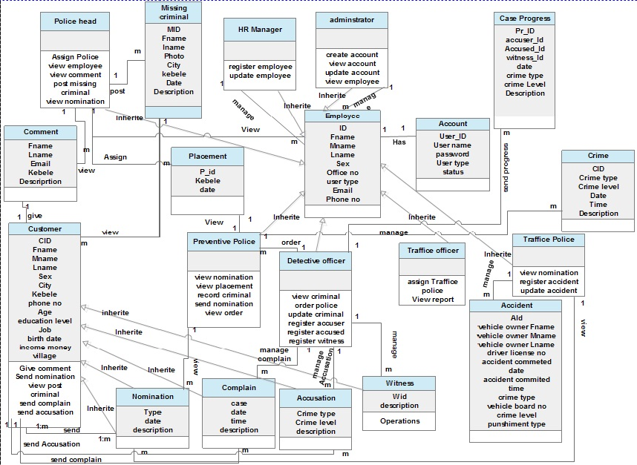

CHAPTER THREE

# 3. System Design

**Introduction**

The term design describes a final system and the process by which it is developed it refers to the technical specification that will be applied in implementing the proposed system. It also include the construction of program and design of output, input, code, database and process of the system

System design is the transformation of the analysis model into a system design model. Up to now we were in the problem domain. System design is the first part to get into the solution domain in a software development.

The main purpose of system design is to determine how the system is going to build and to obtain the information needed to direct the actual implementation of the system. It focuses on understanding the model how the software will be built.

# 3.1. Design Class Diagram

Class diagram in the Unified Modeling Language (UML) is a type of static structure diagram that describes the structure of a system by showing the system's classes,

* Their attributes,
* Operations (methods)
* And the relationships among the classes.

A class diagram is an illustration of the relationships and source code dependencies among classes in the Unified Modeling Language (UML). It provides an overview of the target system by describing the objects and classes inside the system and the relationships between them.



Figure 11: Criminal Management Design Class Diagram

## 3.1.1. Description of design class diagram

Table 10: Complaint class diagram Description

|  |  |  |
| --- | --- | --- |
| Attribute | Purpose | Data type |
| CID | Represent as complaint unique identifier | Varchar(30) |
| Fname | Represent the name of the complaint itself | Varchar(30) |
| Lname | Represent the complaint father name | Varchar(30) |
| sex | Represent the sex of the complaint | Varchar(2) |
| city | City the complaint lived | Varchar(30) |
| kebele | kebele the complaint lived | Varchar(30) |
| Phone_no | Represent the complaint phone address | int |
| Job | Represent the compliant occupation | Varchar(30) |
| case | The reason the complaint want to complain | Varchar(30) |
| date | Represents the date that complaint send their request | date |
| description | The detail explanation of the case. | text |

Table 11: Accusation class diagram Description

|  |  |  |
| --- | --- | --- |
| Attribute | Purpose | Data type |
| AID | Represent as Accusation unique identifier | Varchar(30) |
| Fname | Represent the name of the Accusation itself | Varchar(30) |
| Lname | Represent the Accusation father name | Varchar(30) |
| sex | Represent the sex of the Accusation | Varchar(2) |
| city | City the Accusation lived | Varchar(30) |
| kebele | kebele the Accusation lived | Varchar(30) |
| Phone no | Represent the Accusation phone address | int |
| Job | Represent the Accusation occupation | Varchar(30) |
| case | The reason the Accusation want to Accusation | Varchar(30) |
| date | Represents the date that Accusation send their request | date |
| description | The detail explanation of the case. | text |

Table 12: Placement class diagram Description

|  |  |  |
| --- | --- | --- |
| Attribute | Purpose | Data type |
| PID | Represent as Police Id describes full information about the police that assigned to the given place | Varchar(30) |
| kebele | kebele the Accusation lived | Varchar(30) |
| date | Represents the date that Accusation send their request | date |

Table 13: method of detective Officer

|  |  |
| --- | --- |
| Method/operation | Function |
| View Criminal | Used to view criminals send from preventive police |
| Register criminal | Used to record one who have different criminal case |
| Update criminal | Used to update criminal status after view case and make decision |
| View complains | Used to view complains request. |
| Register witness | User to record the one who give witness |

# 3.2. **Database design /Physical data model**

The purpose of physical design is to translate logical description of data into technical specification for storing and retrieving data the goal is to create design for storing data that will provide adequate performance and data integrity, security and recovery.

Physical data model represents how the model built in the database. A physical database model shows all table structures, including column name, column data type, column constraints, primary key, foreign key, and relationships between tables. In our system sample database structure is the following.

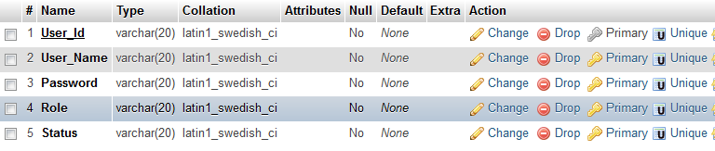Table 14: Account Database Table

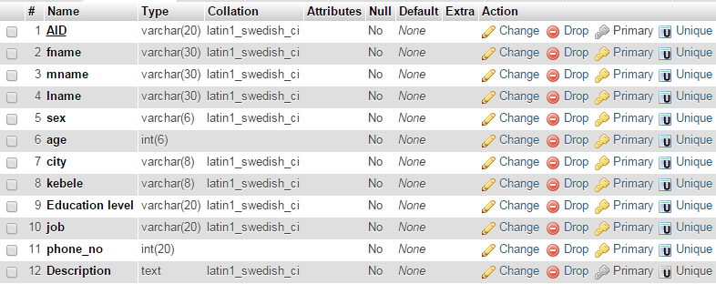

Table 15: Accuser Criminal Database Table

Table 16: Nomination Database Table

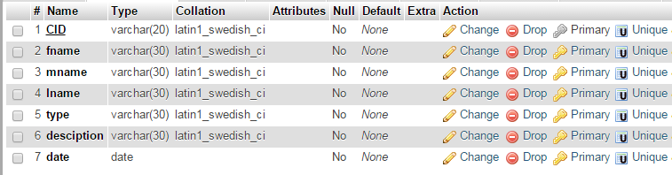

Table 17: Accident Database Table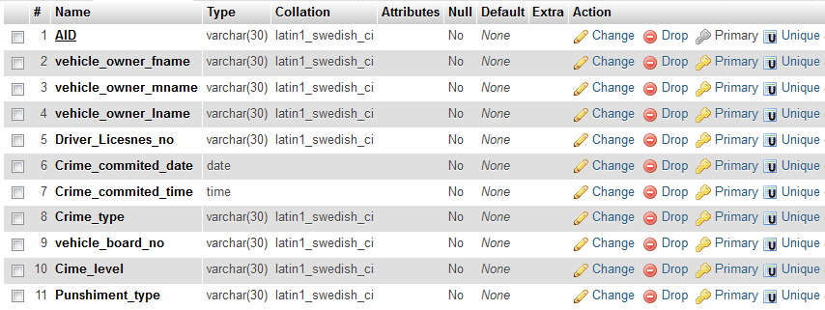

# 3.3. User Interface Design

User interface design is the design of System with the focus on the user's experience and interaction. The main target of user interface design is to make the user's interaction as simple and efficient as possible.

In this system users will communicate with the system through the following user interface links, button, forms and pictures that described under the system. The following some interface design describe the logical characteristics of some interfaces between the system and the users.

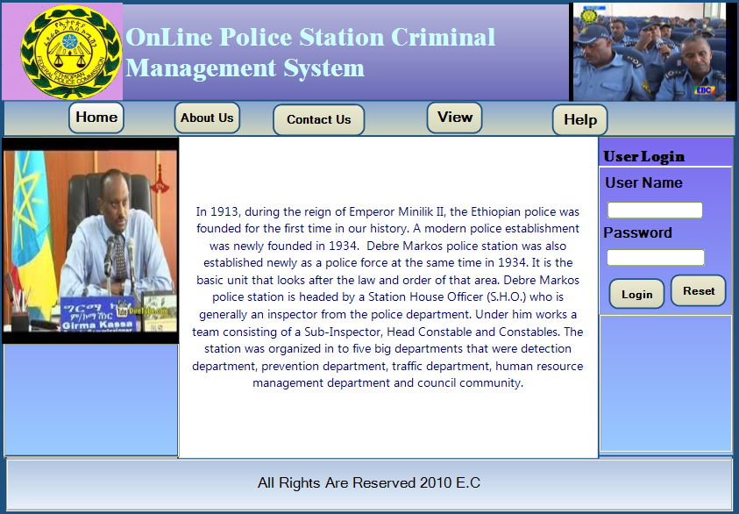

Figure 12: Home page user interface

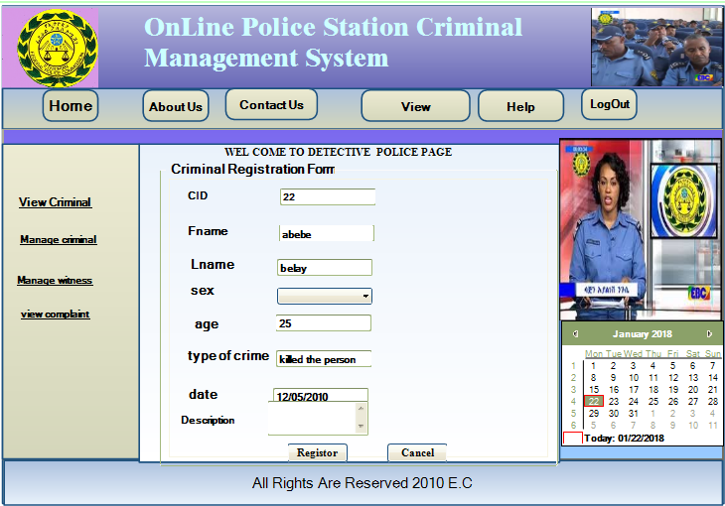

Figure 13: Detective officer page interface

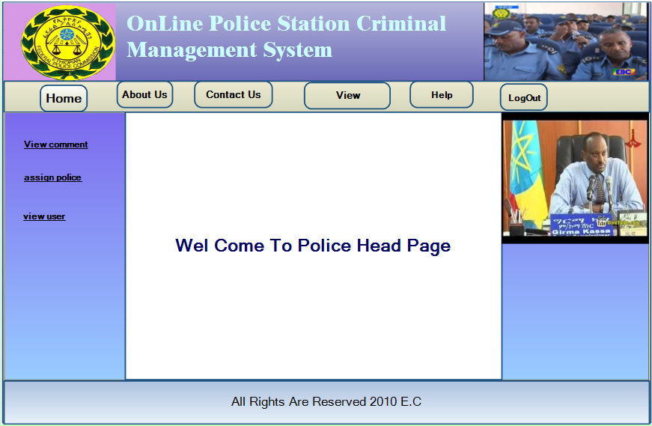

Figure 14: Police head page user interface

# 3.4. System Architecture

## 3.4.1 Deployment Diagram

Deployment diagram shows execution architecture of systems that represent the assignment (deployment) of software artifacts to deployment targets (usually nodes). Nodes represent either hardware devices or software execution environments.

Deployment diagrams are used to model the hardware that will be used to implement the system the link between different item of hardware and the deployment of software on to that hardware.

Through deployment diagram we are able to model

* Where hardware is located
* Where software is located
* 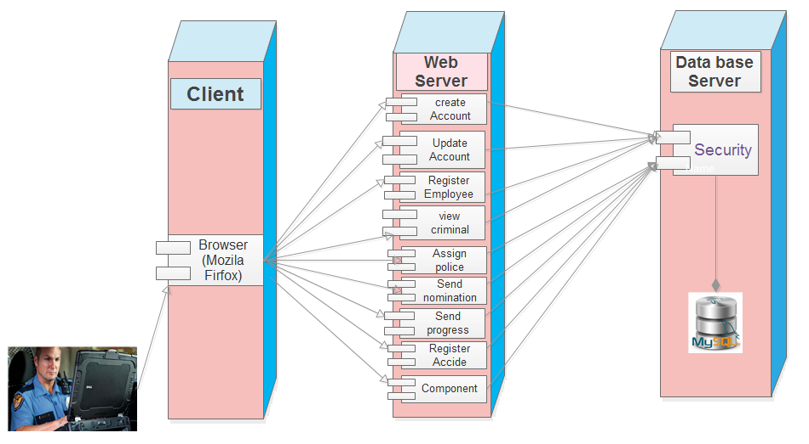What is the communication path between various hardware parts

Figure 15: Deployment Diagram

# Reference

[1]. “introduction about impact of information technology," 23: December 2010. [Online].

[2]. "about System Requirement Analysis," 14 December 2010. [Online]. Available:

http://techpedia.sristi.org/parojects/online-crime-management-system/185558

[3]. "about Non-Functional System Requirement Analysis," 14 December 2010. [Online]. Available:

http://www.scaledagileframework.com/nonfunctional-requirements/

[4]. "about System Requirement Analysis," 14 December 2010. [Online]. Available:

https://books.google.com.et/books/about/System_Requirements_Analysis.html?id=FkpqAnHUNLYC&redir_esc=y

[5]. “UML Use Case Diagrams," 21 December 2010. [Online]. Available:

http://agilemodeling.com/style/useCaseDiagram.htm

[6]. “Use Case Description," 21 December 2010. [Online]. Available:

http://www.dummies.com/business/business-strategy/how-to-create-use-case-description-for-your-business-analysis-report/

[7]. “about Sequence Diagram,” Accessed 28 December 2010.

[Online]. Available: http://www.agilemodeling.com/artifacts/sequenceDiagram.htm

[8]. “about UML Activity Diagram,” Accessed 28 December 2010.

https://www.tutorialspoint.com/uml/uml_activity_diagram.htm

[9]. “about UML Analysis class Diagram,” Accessed 30 December 2010.

[Online]. Available: https://www.lucidchart.com/pages/uml-class-diagram